## WEEK-2

**Key Topics: ServiceNow Admin Full Course**

**Sub-topics: Platform Overview and Architecture, User Interface and Branding, List & Filters and Forms, Task Management, Notifications, Knowledge Management, Service Catalog, Tables and Fields, Access Control List, Data Import, CMDB, Integration, Update Sets, Events, Platform Stats**

* ServiceNow is a cloud-based platform providing infrastructure to develop, run, and manage applications across various business functions

**Overview of the ServiceNow platform and architecture.**

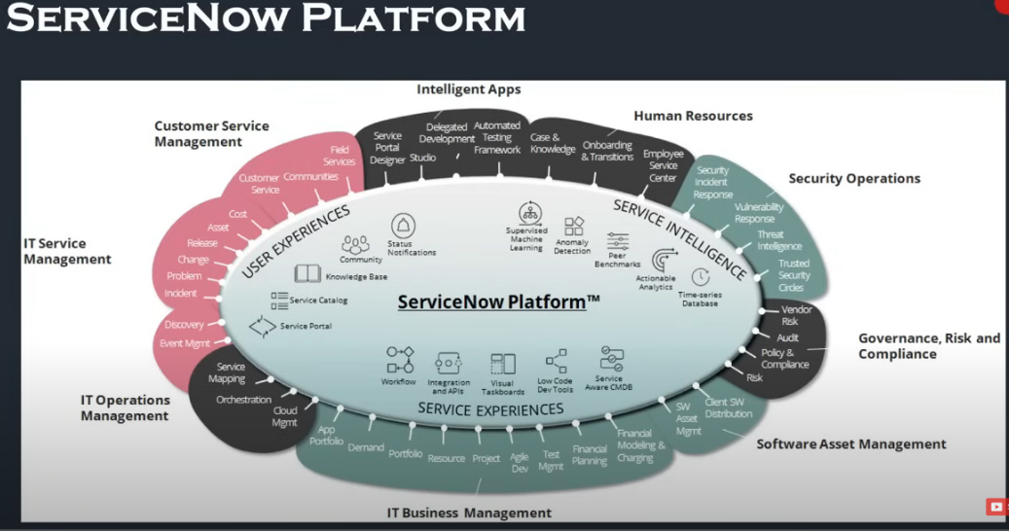

* The platform features a multi-instance architecture, ensuring data isolation and communication between instances. It also offers high availability and regular data backups.

**Multi-tenant Architecture**

This is multi tenant and multi-instance architecture in which every organization has their own instance

**ServiceNow platform interface**

* ServiceNow offers three main interfaces: native UI, mobile apps, and service portal, all accessing the same data model.
* The native UI is the primary interface for interacting with ServiceNow applications. Supported browsers include Chrome, Edge, Firefox, and Safari.
* ServiceNow mobile apps—ServiceNow Agent, Now Mobile, and Onboarding—are designed for different user roles and needs, enhancing productivity on the go.
* The service portal provides a user-friendly self-service experience, allowing users to request services, search knowledge articles, and access information.

**Role Based Access in ServiceNow**

Role-based access ensures that applications can identify users and control their access based on their roles, using entities like users, groups, and roles.

* USER – Users are assigned to groups and multiple roles to determine what they can access and do within the platform.A user is represented as a record in the sys_user table.
* GROUP- A Group is a collection of users who share a common purpose or responsibility, such as being part of the same department or team. Groups help manage user permissions and workflows more efficiently. Instead of assigning roles to individual users, roles can be assigned to a group, allowing all members of the group to inherit those permissions.This concept of a group is stored as a record in the sys_user_group table.
* ROLE – A Role is like a set of permissions that decides what a user can do and see in the system. Roles are assigned to users to manage what they can access, and they help set up rules for who can do what in the system.All roles are listed in the sys_user_role table.

There are 3 main screen elements: -

1. Banner Frame

2. Application Navigator

3. Content Frame

**Application Navigator:**

⦁The Application Navigator in ServiceNow is a component located on the left side of the interface that provides a way for users to quickly access different applications, modules, and functionalities within the platform.

⦁Applications are the Collection of files and data, they serve as the building blocks for delivering services such as IT, HR resource management, Service Desk etc. Modules are the individual functionalities or operations available under each Application.

⦁We can Pin the Applications and modules to favorites for quick access. We can use the Favorites to mark the application that we frequently use and have quick access to it. We also have a history option to look at our recent actions. Default is last 30 items we have accessed

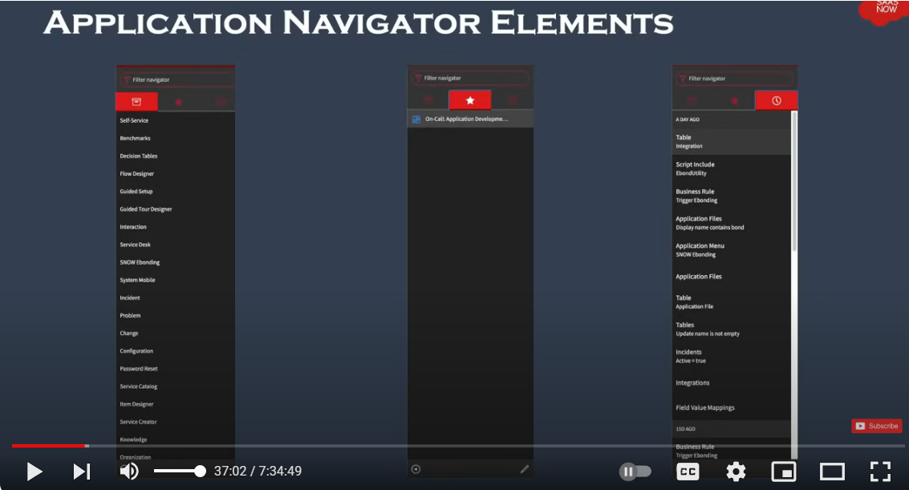

**Branding Overview**

* Branding involves customizing the instance to reflect the company's identity, including changing the logo, name, and color theme.
* Configuration options for branding are accessible via the UI16 configuration module, where users can change images and text.
* Additional settings for welcome page content and other UI elements can be customized to enhance the user experience.

**LISTS AND FILTERS**

**Lists**

Lists show records from a table in a grid or table format, making it easy to view, filter, and sort multiple records at once. Each database table in ServiceNow has its own list view.

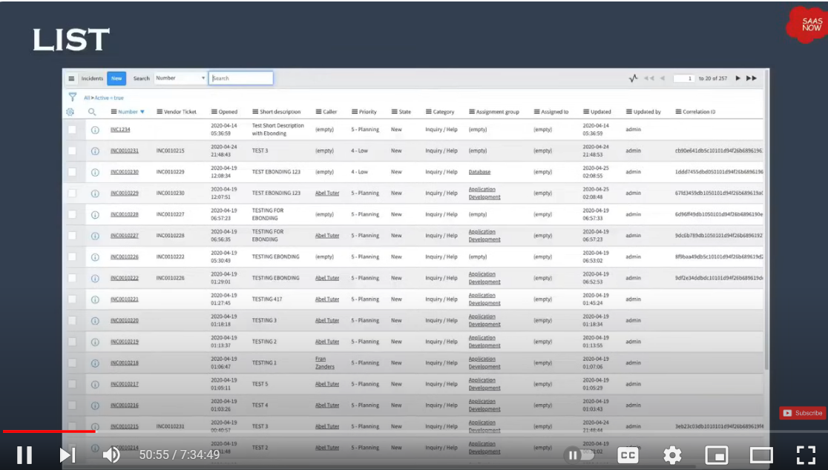

You can access lists in three ways:

⦁Application Navigator: Navigate to the list through the application navigator by selecting the appropriate module.

⦁Dot List Command: Use the dot command (e.g., incident.list) in the application navigator to quickly open the list.

⦁Sys_db_object Command: Use the sys_db_object.list command to see a list of tables, then select the one you want.

Using Table_name.list opens the list view of a specific table, and Table_name.LIST will open it in a new tab.

The List Header in ServiceNow provides several tools to help you manage and interact with lists:

⦁List Controls: These are options for actions you can take on the list or its items.

⦁List Control Menu: Includes options like changing views, applying filters, grouping items, refreshing the list, and creating favorites.

⦁Column Option Menu: Lets you configure the column settings, import data, create reports, and sort the list.

⦁List Field Menu: Used to copy the sys_id of a record, which is a unique identifier in ServiceNow.

⦁Filter Lists: Allows you to search and apply filters to narrow down the list of records.

⦁Table Search Bar: Enables you to search for specific records within the list.

⦁Personalize Icon: Lets you customize the list view to fit your preferences.

**Filter**

A filter in ServiceNow is used to narrow down the data in a table list by applying specific conditions. Here are the three main parts of a filter condition:

⦁Field: This is the specific data field you want to filter by. It includes options from the table you’re working with and can also include fields from related tables through dot-walking.

⦁Operator: This defines how the filter should compare the field’s value. The options vary depending on the type of field you are filtering (e.g., “is,” “contains,” “is greater than”).

⦁Value: This is the criteria you are looking for in the field. It can be a text entry or a choice from a list, depending on what type of data the field holds.

Steps to Create a Filter in a List

⦁Open the List:

⦁Navigate to the list where you want to apply the filter (e.g., Incidents, Change Requests).

⦁Access Filter Options:

⦁Look for the Filter icon or menu, usually located in the list header. It might look like a funnel or be labeled “Filter.”

⦁Create a New Filter:

⦁Click on the Filter icon or menu, then select Create Filter or Add Filter Condition.

**Breadcrumbs**

The Breadcrumbs Filter conditions applied to the list are summarized in the breadcrumbs, shown in blue letters across the top of the list. Not only do the breadcrumbs provide an “at-a-glance” view of the filter’s conditions, but they allow you to modify conditions as necessary. For example, you can select the greater than sign before a condition to remove that condition or select a breadcrumb to remove all of the conditions that follow. Group By - It is used to group the list records based on a field. Refresh List - Used to refresh list to reflect the recent changes.

Group By: This feature allows you to organize the list records based on a specific field, grouping similar records together for easier viewing.

Refresh List: Use this option to update the list and reflect any recent changes or updates.

**List Personalization**

List Personalization lets you customize how a list appears for your own use without changing the default layout for everyone. Here’s what you need to know:

⦁Personalize List: This feature allows you to adjust the layout and display of a list just for yourself. These changes are specific to your user account and don’t affect how others see the list.

⦁Temporary Customization: Personalization are meant for temporary adjustments. If the system or admin makes global changes to the list view, you won’t see those changes in your personalized list until you reset it.

⦁Reset to Column Defaults: If the system administrator updates the default list view, you won’t see these updates until you choose to reset your personalized list to the default settings.

**List Layout Configuration**

List Layout Configuration in ServiceNow involves adjusting the columns or fields displayed in a list view. This is typically done by administrators and affects how all users see the list. Here’s how to configure the list layout for a table:

⦁Navigate to the List:

⦁Go to the list you want to configure and make sure you’re viewing it in the correct mode or view.

⦁Access Column Options Menu:

⦁Click on the options menu for any column in the list (usually represented by a gear icon or similar).

⦁Configure the List Layout:

⦁Select Configure from the menu.

⦁Choose List Layout to open the configuration options.

**Forms**

Forms are user interfaces that allow you to view, create, and edit records in the database. Each record type is linked to a specific table, and there are thousands of forms available to manage the extensive data structure within ServiceNow. Forms help users interact with and manage data effectively by providing a structured way to input and display information.

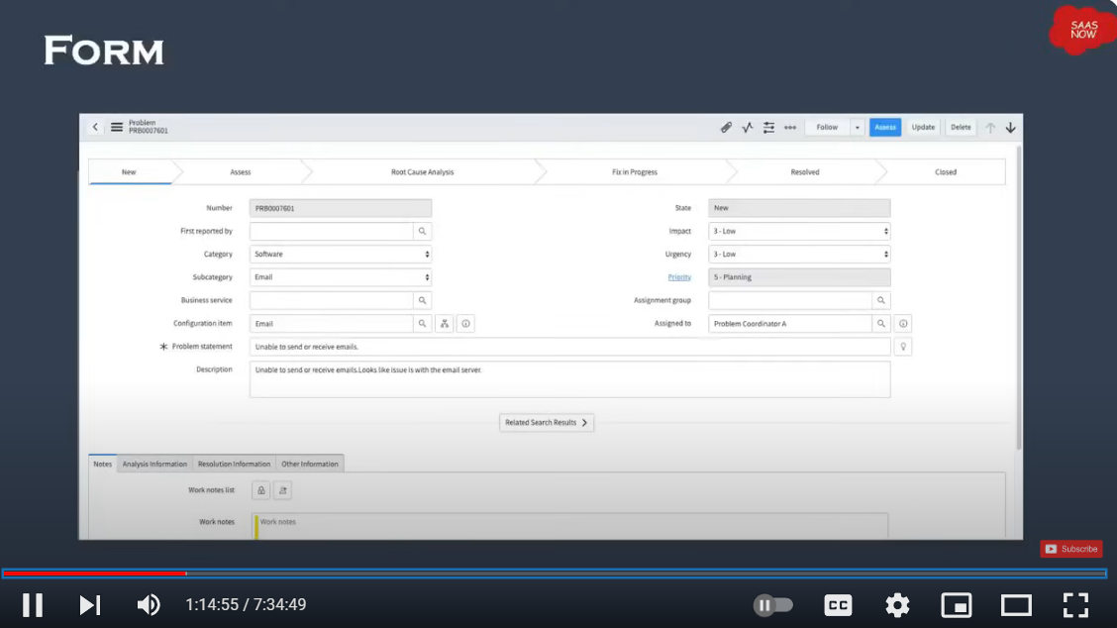

**Header Bar:**

⦁The header bar is the section at the top of a form or list that provides key information and controls related to the record or list.

Read-Only Fields:

⦁These fields display information that users cannot edit. They are often used for data that should be viewed but not changed, like record IDs or system-generated timestamps.

Required Fields:

⦁These fields must be filled out before the form can be saved or submitted. They are marked with an asterisk (*) or other indicators to show that they are mandatory.

Sections:

⦁Organize fields into logical groups to improve form readability and usability.

**Formatter:**

⦁Displays additional information or instructions that aren't part of the standard fields.

Related Lists:

⦁Show records from related tables that provide context or additional information about the current record.

**Fields:**

⦁Fields in ServiceNow forms are the individual elements where users input, or view data related to a record. Each field corresponds to a specific type of information.

**Field types**

⦁Reference Field: Allows users to select records from another table.

⦁Document ID: Provides a way to select records from multiple tables using a unique identifier.

⦁Date/Time: For selecting dates and times, often with a calendar widget.

⦁String: For entering text, including letters, numbers, and special characters.

⦁Choice List: Provides a drop-down menu of predefined options for users to choose from.

⦁True/False: Represents binary choices using a checkbox, where checking the box indicates "True" or "Yes," and leaving it unchecked indicates "False" or "No."

* Saving Changes:Saving changes to your records is a manual process.

⦁Submit: This action saves the changes and closes the form. For new records, the button will say "Submit." For existing records, it will say "Update."

⦁Save: This option saves your changes but keeps the form open, allowing you to continue making modifications.

⦁Unsaved Changes Warning: If you try to navigate away from the form without saving, you will receive a warning about the unsaved changes. This alert will prompt you to either save or discard the change before leaving the form.

**Form Formatters**

Formatters are used to display information on a form that isn't stored as a standard field. They help enhance the user interface by showing additional context or data. Its types are

⦁Activity Formatter: Shows a list of activities or history related to the record. This includes journal entries like comments and work notes. Helps track changes and communications associated with the record.

⦁kProcess Flow Formatter:Displays the different stages of a process in a linear flow at the top of the record. Provides a visual representation of the record's progress through various stages.

⦁Parent Breadcrumbs Formatter: Shows breadcrumbs indicating the parent or related tasks of the current record. Helps users navigate through hierarchical relationships and see the context of the current task.

⦁Approval Summarizer Formatter: Provides a dynamic summary of the request being approved. Gives a concise overview of the approval request details and status.

⦁CI Relations Formatter: Displays the Configuration Item (CI) form and shows the relationships between the current CI and other related CIs.Helps visualize how different CIs are connected and their dependencies.

**Form Templates**

Form Templates in ServiceNow make it easier to create new records by using pre-set forms with some fields already filled in. This saves time and avoids repeating the same data entry.

**Form Design Tool:**

⦁A drag-and-drop tool that lets you easily move and arrange fields on a form.

⦁Makes it simple to design and change how forms look by letting you place fields and sections wherever you need them.

**Form Layout Device:**

⦁A tool for managing which fields appear on a form and how they are arranged.

⦁Makes it easy to add or remove fields from the form to fit your needs.

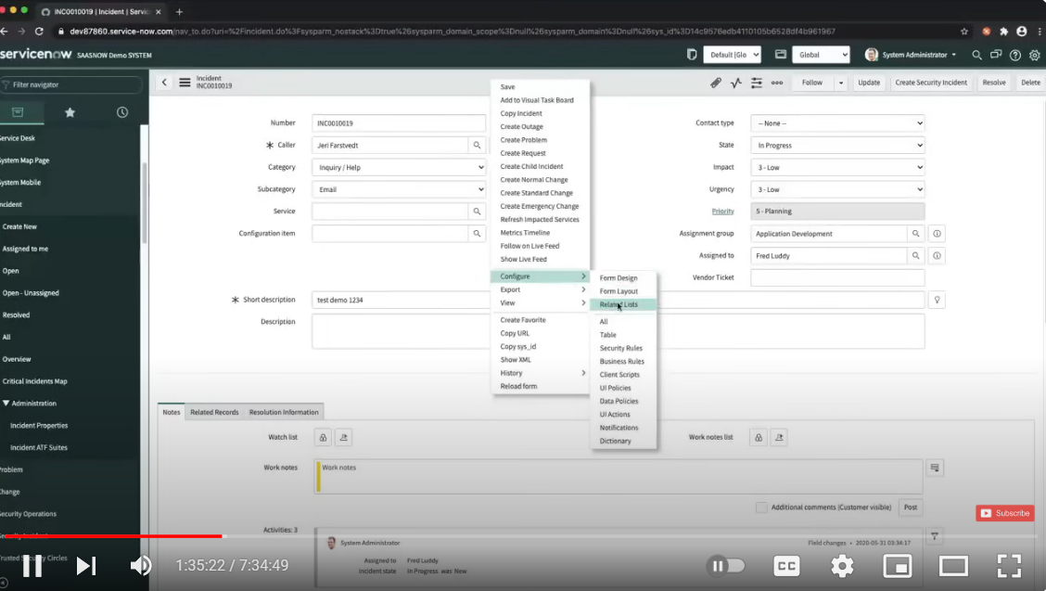

**What is a Task?**

* Tasks can be records assigned to users or groups, including incidents and requests.
* Tasks are essential for tracking progress and actions assigned to teams or individuals, like resolving IT issues or onboarding new employees.

**Task Table**

* The task table is a core table that contains various types of tasks, including incidents, changes, problems, and more. This table is part of the IT Service Management (ITSM) application and serves as a foundational table for managing tasks across different modules.
* The task table is a foundational table used to manage various types of tasks. Several other tables extend the task table to handle specific types of tasks, such as incidents, requests, and changes.

### **1. Incident Table**

**Table Name**: incident

* The incident table extends the task table to manage incident records. Incidents are typically used to track unplanned interruptions or reductions in quality of IT services.

### **2. Request Table**

**Table Name**: sc_request

* The sc_request table extends the task table to manage service requests submitted through the Service Catalog. A request represents a user's request for a service or item.

### **3. Change Table**

**Table Name**: change_request

* The change_request table extends the task table to manage change requests. Change requests are used to track changes to IT services and infrastructure, ensuring changes are made in controlled manner.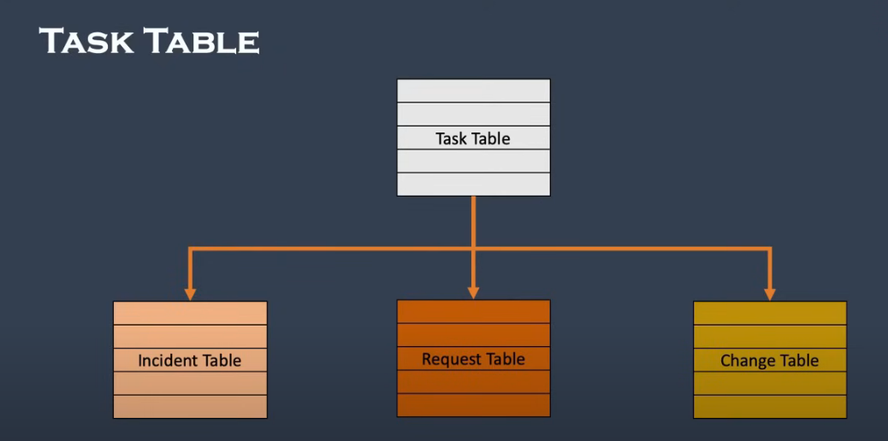

**Task assignment**

Task assignment in ServiceNow is a crucial component for managing and streamlining workflows and ensuring that tasks are completed efficiently

**.Ways for Task assignment**

### **1. Manual Task Assignment**

* Direct Assignment: Users can directly assign tasks to individuals or groups by updating the assignment fields on the task form. This method is often used for ad-hoc or one-off tasks.
* Assignment Group: You can assign tasks to a specific group, allowing any member of the group to pick up and work on the task. This is useful for collaborative environments where multiple team members may be responsible.

### **2. Assignment Rules**

* Creation of Assignment Rules: Define rules to automate the assignment of tasks based on specific conditions (e.g., task type, priority). For example, you might create a rule that assigns all high-priority incidents to a specialized team.
* Rule Configuration: Set up conditions, actions, and scripts within assignment rules to control how tasks are distributed. These rules are applied when a task is created or updated.

**NOTIFICATIONS**

* Notifications are a key feature used to inform users about various events or changes in the system. They can be configured to send out emails, text messages, or other forms of alerts based on specific conditions or triggers.
* "inbound" and "outbound" notifications refer to different aspects of how the system handles notifications and communication with users or external systems.

### **Inbound Notifications**

Inbound Notifications refer to messages or data received by ServiceNow from external sources. This typically involves processing incoming emails, web service requests, or other forms of data input.

### **Outbound Notifications**

Outbound Notifications are messages sent from ServiceNow to users or external systems. These notifications can be in the form of emails, SMS, or other communication methods. The primary goal is to keep stakeholders informed about changes, updates, or important events.

### **Managing Notifications**

To manage and configure both inbound and outbound notifications, follow these steps:

1. Navigate to Notifications:
   * For outbound notifications, go to the Notification module. Here you can create new notifications or modify existing ones.
   * For inbound email actions, navigate to the Inbound Actions module to set up rules and actions for processing incoming emails.
2. Create or Modify Notifications:
   * Define the notification name, conditions, and triggers.
   * Specify recipients, notification format, and content templates.

**OOB Notification**

* Out-of-the-box (OOB) notifications in ServiceNow are predefined notifications provided by the platform to support common use cases and streamline communication processes. These notifications are designed to cover a range of standard scenarios and can be customized as needed.

**Notification Form**

* The Notification Form is where you configure and manage email notifications. This form allows you to define the conditions, recipients, content, and other settings for notifications that are sent out when specific triggers or conditions are met.

### **Opening the Notification Form in ServiceNow**

#### **1. Login to ServiceNow**

* Ensure you are logged into your ServiceNow instance with appropriate permissions (typically, you'll need roles like admin or specific notification-related roles).

#### **2. Navigate to Notifications**

1. Open the Application Navigator:
   * The Application Navigator is on the left side of the ServiceNow interface. It is where you search for and access different modules and records.
2. Find the Email Notifications Module:
   * In the Application Navigator, type “Email Notifications” in the search bar.
   * You should see “Email Notifications” under System Notification. Click on it.
3. Alternatively:
   * Navigate to System Notification > Email Notifications directly if you prefer manual navigation

#### **3. Open an Existing Notification or Create a New One**

1. To Open an Existing Notification:
   * You will see a list of existing email notifications. Click on the name of any notification in the list to open its form for viewing or editing.
2. To Create a New Notification:
   * Click the New button at the top of the list to open a blank Notification Form where you can configure a new notification.

**Knowledge Management**

**Knowledge article**

* Knowledge articles provide information like policies, troubleshooting steps, and resolutions.

**Benefits of Knowledge Management**

* The Knowledge Management application lets users create and maintain knowledge articles, categorized by departments or business units.
* Users can import articles from external files, and articles go through stages like unpublished, published, and retired.
* By capturing and reusing knowledge, organizations can avoid redundant work. This prevents the re-creation of solutions that have already been documented and shared.

**Knowledge Management Application**

* The Knowledge Management application is designed to help organizations capture, manage, and utilize knowledge effectively. The application includes several key modules that work together to facilitate the creation, management, and dissemination of knowledge.

### **1. Knowledge Base**

* The central repository where all knowledge articles are stored. Knowledge bases can be organized into categories and subcategories to make it easier to find and manage content.

### **2. Knowledge Article**

* Individual entries or documents that provide detailed information on specific topics, solutions, or procedures**.**

### **3. Knowledge Management**

* The core module for managing knowledge processes, including article creation, review, publication, and maintenance.

### **4. Knowledge Search**

* The search functionality that allows users to find knowledge articles quickly and efficiently.

### **5. Knowledge Management Analytics**

* Provides insights and reports on knowledge management activities and performance.

### **6. Knowledge Management Administration**

* Tools and settings for configuring and managing knowledge management application features.

### **7. Knowledge Management Reports and Dashboards**

* Create and view dashboards and reports to monitor knowledge management activities and metrics.

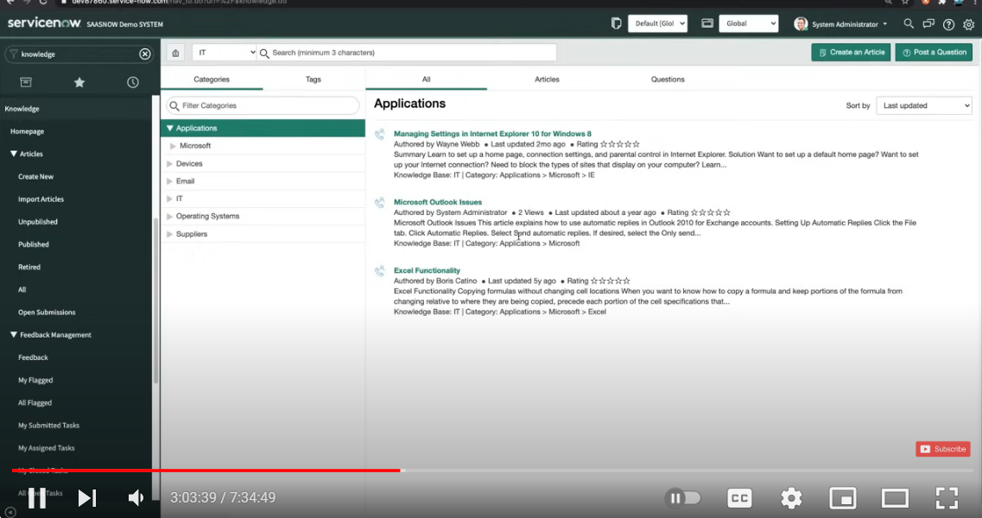

**Knowledge Form**

A Knowledge Form is a structured interface used to create, edit, and manage knowledge articles within the Knowledge Management application. It is designed to capture and organize information in a consistent and comprehensive manner. The form includes various fields and options that facilitate the documentation of knowledge, ensuring that articles are informative, accurate, and easily searchable.

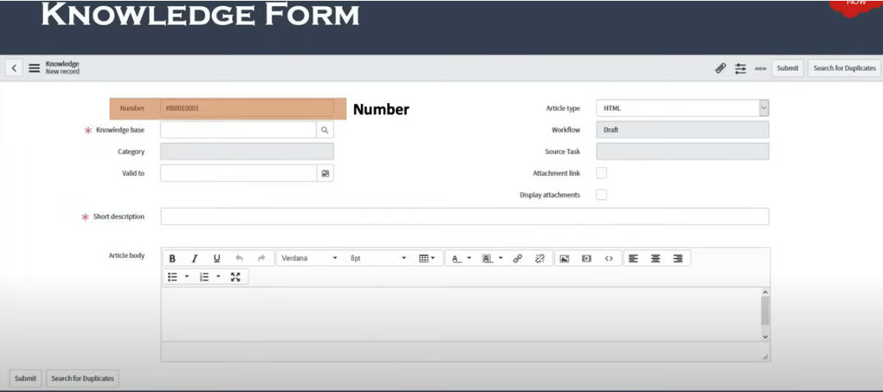

### **1.Number**

* The Number field is used to uniquely identify each knowledge article. This field is essential for referencing, tracking, and managing articles within ServiceNow.

### **2. Knowledge Base**

* Indicates the knowledge base to which the article belongs. Select from predefined knowledge bases to categorize the article appropriately.

### **3. Category**

* Further organizes the article within the selected knowledge base.Choose a specific category or subcategory that best describes the content of the article.

### **4. Article Type**

* Specifies the type of content being created. Helps in classifying the nature of the article and applying relevant templates or formats.

### **5. Short Description**

* Provides a brief summary of the article’s content.This should be a short, clear statement that gives users an overview of what the article is about.

### **6.Description / Body**

* Contains the detailed content of the article. This is typically a rich text editor area where the main body of the article is written. It includes formatting options such as bold, italic, lists, headings, and hyperlinks.

### **7. Attachments**

* Allows the addition of files or documents related to the article.Upload files such as images, PDFs, or other relevant documents to support the article’s content.

### **8.Workflow**

* A workflow in ServiceNow is a visual representation of a series of automated steps that drive processes and tasks to completion. It defines the sequence of actions, approvals, and decisions needed to manage business processes efficiently.

### **9. Source Task**

* A source task in ServiceNow refers to a task that originates from a workflow or process and needs to be completed as part of a larger process. Source tasks are often generated by workflows or automation rules and are tracked through the ServiceNow task management system.

**Knowledge Management Workflow**

The Knowledge Management Workflow helps automate and manage the lifecycle of knowledge articles. This workflow ensures that knowledge articles are created, reviewed, approved, and published in a consistent and efficient manner.

1.**Create Article**

* A new knowledge article is created.The article is saved in a draft state.

**2.Submit for Review**

* The author submits the draft article for review. The article is assigned to reviewers or approvers.

**3.Review and Approve**

* Reviewers evaluate the article.
  + Approve: If the article meets standards, it is approved.
  + Reject: If it does not meet standards, it is rejected with comments for revisions.
  + Request Revisions: If changes are needed, reviewers can request modifications from the author.

**4.Publish Article**

* The article is approved. The article is published and made accessible to the intended audience..

**5.Collect Feedback**

* Users access the published article. Users provide feedback or rate the article. Feedback is collected and reviewed for potential updates.

**6.Review and Update**

* Scheduled review cycle or feedback indicates the need for updates.The article is revised and updated as necessary.

**7.Archive Article**

* The article is outdated or no longer relevant.The article is archived and removed from active visibility but retained for historical reference if needed.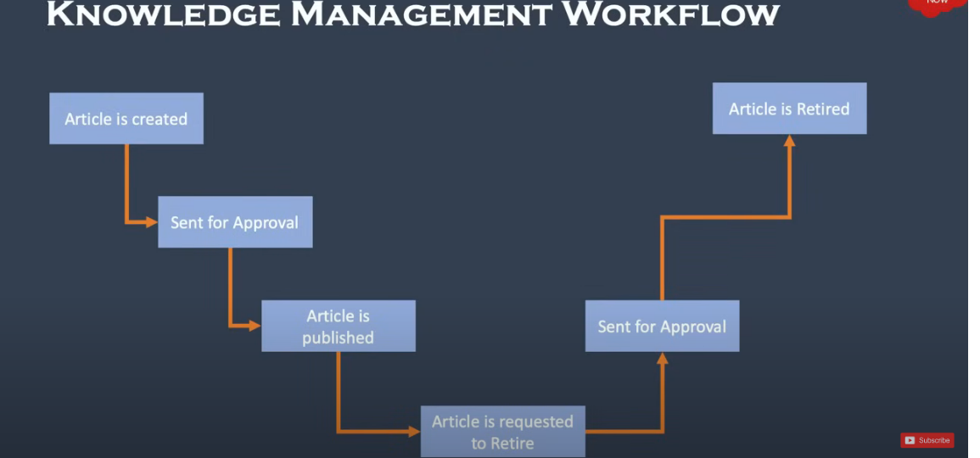

**Service Catalog**

* In a ServiceNow Service Catalog, you can organize and manage a wide variety of services and products under different categories.

### **1. Services**

**Purpose**: This category typically includes non-tangible items like support services, consulting, or administrative requests.

### **2. Hardware**

**Purpose**: This category includes physical equipment and devices that users can request.

### **3. Software**

**Purpose**: This category encompasses software applications and tools that users can request.

### **4. Desktop**

**Purpose**: This subcategory under hardware may specifically focus on desktop computers and related

### **5. Mobiles**

**Purpose**: This category includes mobile devices that users can request.

### **6. Peripherals**

**Purpose**: This category covers accessories and additional devices that enhance or complement

### **7. Can We Help You?**

**Purpose**: This section is designed to assist users who might not find what they are looking for in the standard catalog categories.

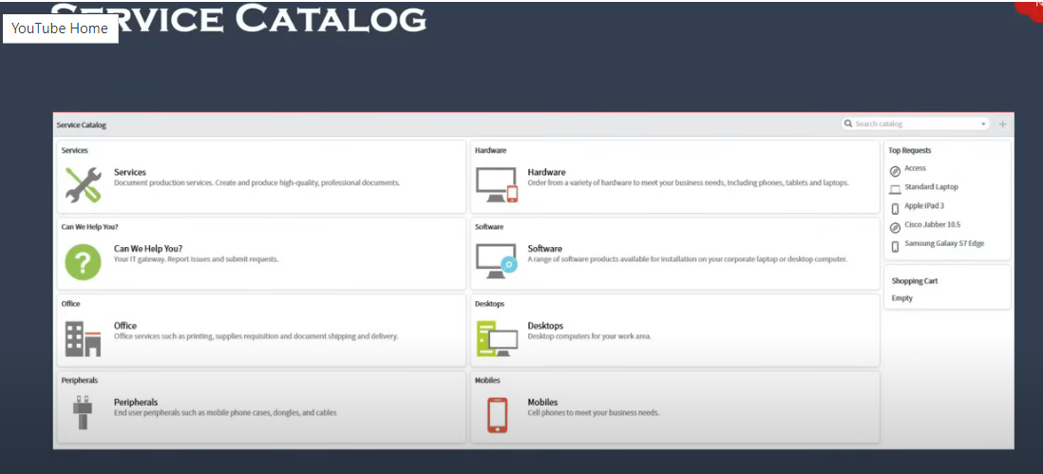

**Benefits of Service Catalog**

### **1. Enhanced User Experience**

### **2. Improved Efficiency**

### **3. Increased Transparency**

### **4. Better Resource Management**

### **5. Enhanced Service Delivery**

**TABLES AND FIELDS**

* Tables and columns are essential for organizing and managing data within the platform. Below is a comprehensive overview of some key tables and their columns across various functional areas in ServiceNow, including the Service Catalog, Incident Management, Change Management, and more.

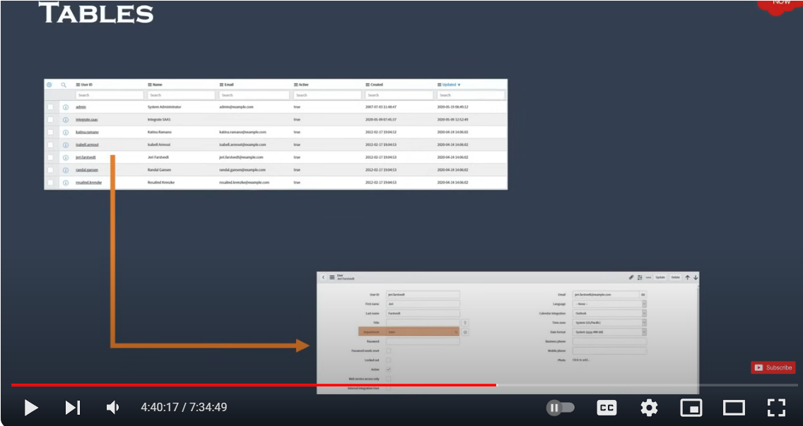

**FIELDS**

* Fields are individual pieces of data within a table. They represent the specific attributes or properties of the records in that table. Each field in a table is associated with a particular type of data, such as text, numbers, dates, or references to other records.

### **1. Field Label**

* The field label is the user-friendly name that appears on forms and lists to describe what the field is for. It is what end users see and interact with.
* The label provides a clear description of the data that should be entered or viewed in the field. It helps users understand the purpose of the field without needing to know the technical details.

### **2. Field Name**

* The field name (also known as the internal name) is the technical identifier for the field in the database. It is used by ServiceNow and developers to refer to the field programmatically.
* The field name is used in scripting, queries, and integrations to access or manipulate the field’s data. It is crucial for backend operations and is not typically displayed to end users.

### **3. Field Value**

* The field value is the actual data or content stored in the field for a particular record. It represents the information that has been entered or selected by the user.
* The value is what users see and interact with, and it is stored in the database as part of the record. It can be text, numbers, dates, references, or other types of data depending on the field type.

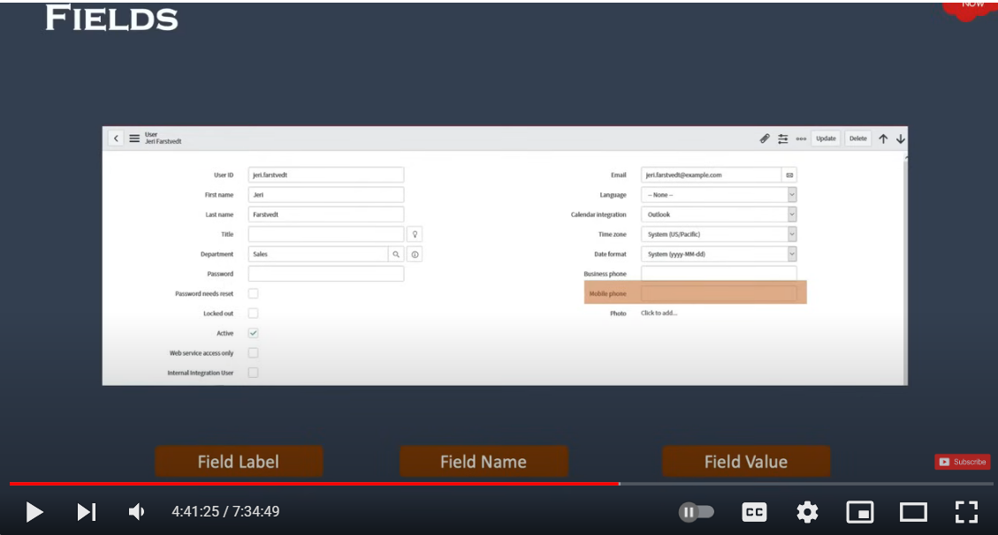

**TYPES OF TABLES**

* Tables are categorized based on their purpose and relationship with other tables

### **1. Base Tables**

Base tables are foundational tables in ServiceNow that serve as the primary data structure for various applications. They provide the fundamental structure and fields used by other tables.

### **2. Extended Tables**

Extended tables inherit fields and functionality from base tables. They allow for additional customization and specialization without altering the original base table.

### **3. Core Tables**

Core tables refer to the foundational tables provided by ServiceNow out of the box. They are essential for the functioning of ServiceNow’s core applications and modules.

### **4. Custom Tables**

Custom tables are created by users or developers to meet specific business requirements that are not covered by the standard base or core tables. They are tailored to fit unique needs of an organization.

**ACCESS CONTROL LISTS**

* Access Control Lists (ACLs) are a critical feature used to define and enforce security rules for records, fields, and other objects in the platform. ACLs ensure that users have appropriate permissions to view, create, update, or delete data according to their roles and responsibilities.

**Operations Restricted**

Access Control Lists (ACLs) are used to control access to various operations on records, fields, and tables. The operations that can be restricted through ACLs are typically related to CRUD (Create, Read, Update, Delete) actions.

### **1. Create**

* This operation controls whether a user can create new records in a table.

### **2. Read**

* This operation determines whether a user can view records in a table.

### **3. Update**

* This operation controls whether a user can modify existing records in a table.

### **4. Delete**

* This operation determines whether a user can delete records from a table.

### **5. Execute**

* The Execute operation pertains to the ability to run business rules, scripts, and other server-side operations that affect the behavior of records.

**6. Save as Template**

* The Save as Template operation allows users to save the current record or configuration as a template that can be reused to create new records with similar attributes.

### 

### **7. Report On**

### The Report On operation allows users to generate reports based on the data in a table. This action controls whether users can create and run reports on specific tables or records.

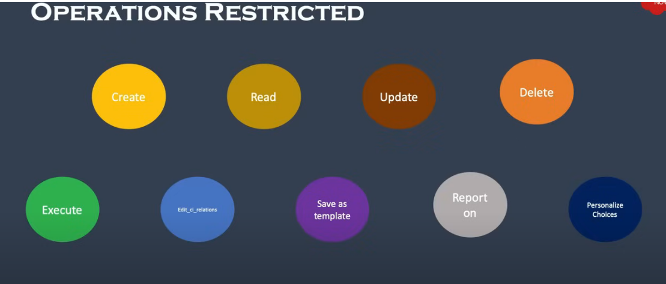

**HOW ACL WORKS**

1.User logins to servicenow and access a record.

2.System finds ACL for same objects.

3.System finds the matching rule.

4.If match found, evaluates the ACL

5.else grant access

6. Pass the ACL

7.Access not granted

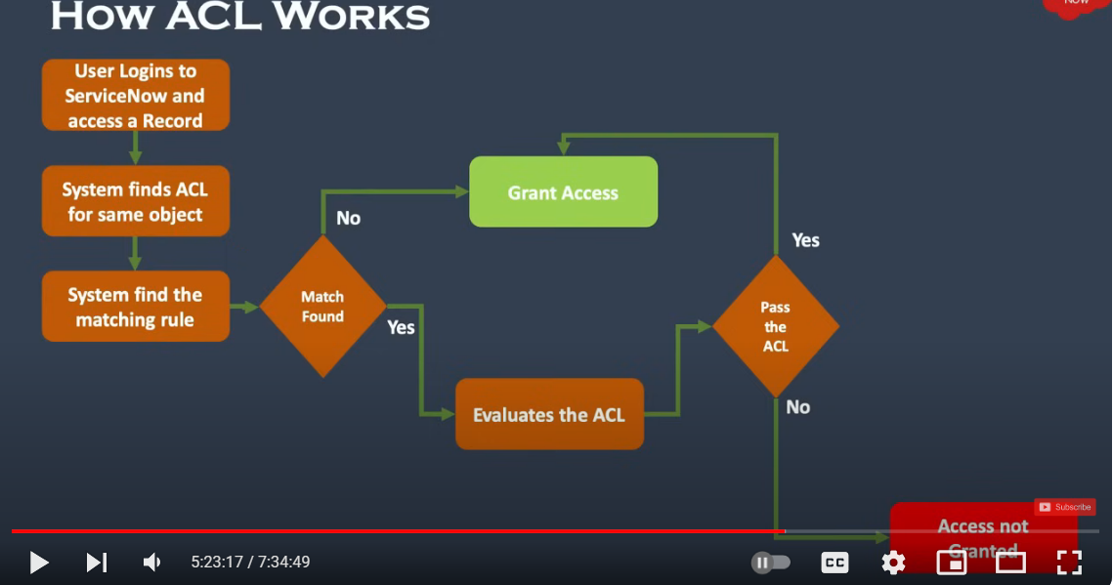

**Data Import**

* Data import in ServiceNow involves bringing data from external sources into the ServiceNow platform. This can be crucial for setting up ServiceNow instances, migrating data from other systems, or integrating with external applications.

**Import set components**

### **1.Data Source**

* Defines the origin of the data to be imported into ServiceNow. This can be a CSV file, Excel file, XML, JDBC source, or other supported formats.
* Specifies where the data comes from and how it should be imported into the Import Set Table.

### **2.Import Set Table**

* A staging table where data is initially loaded before it is transformed into the target table. Each import set creates a temporary table specific to the import job.
* Provides a temporary storage area for data where you can review, clean, and prepare the data for transformation.

### **3. Transform Map**

* Maps fields from the import set table to the target table, defining how data should be transformed and imported.
* Transforms data from the import set table into the correct format and location in the target table.

### **4.Mapping Assist**

* Mapping Assist is a feature in ServiceNow that helps users map fields from an import set table to a target table. It simplifies the process of creating and managing field mappings by providing a user-friendly interface.

### **5. Coalesce**

* Coalesce is a feature in ServiceNow used during data import to determine how records in the import set table should be matched or updated in the target table. It helps in identifying existing records and avoiding duplicates by defining which fields should be used to match records.

### **6.Target Table**

* The Target Table is the table in ServiceNow where the data from the import set table will be finally loaded or transformed. It is the destination for the data after it has been processed according to the rules defined in the transform map.

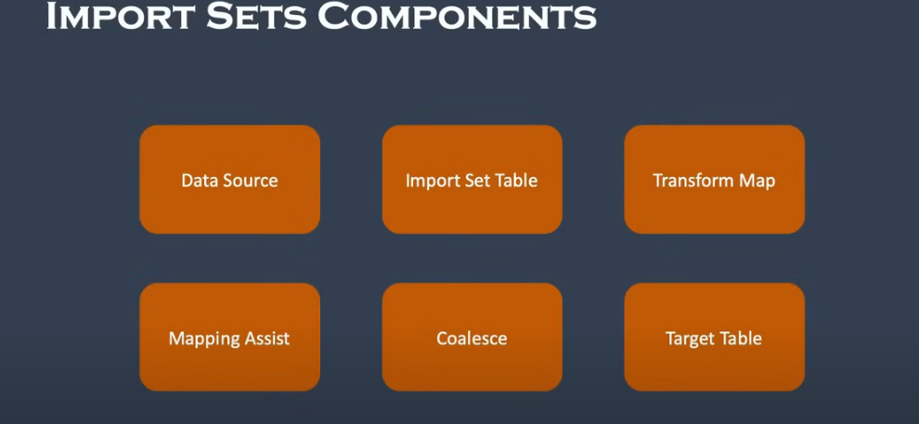

**Configuration Management Database**

* The Configuration Management Database (CMDB) is a core component of IT Service Management (ITSM) within ServiceNow. It serves as a centralized repository that stores information about configuration items (CIs) and their relationships. The CMDB is essential for managing and understanding the IT infrastructure, services, and dependencies within an organization.

**Configuration item(CI)**

* A Configuration Item (CI) is any component or service asset that needs to be managed to deliver IT services. CIs can include hardware, software, documentation, and services. They are tracked in the CMDB to help organizations understand their IT environment, manage IT operations, and ensure service delivery.

**CI Dependency View**

* The CI Dependency View in ServiceNow is a visual representation of the relationships and dependencies between Configuration Items (CIs) within the Configuration Management Database (CMDB). This view helps users understand how different CIs are connected, which can be crucial for impact analysis, change management, incident resolution, and overall IT operations.

**CI Class Manager**

* The CI Class Manager in ServiceNow is a tool used to manage and organize the various Configuration Item (CI) classes within the Configuration Management Database (CMDB). CI classes define the types of configuration items and their associated attributes. Managing these classes effectively is crucial for maintaining an accurate and functional CMDB.